**Step 1: Drawing Basic Shapes With Python Turtle**

1. Create an new Repl by selecting the **“Python with Turtle”** language / environment.

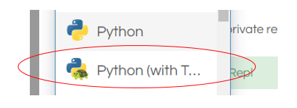.

1. Begin all of your turtle programs with the following code to create a “pen”:

import turtle

myPen = turtle.Turtle()

1. Review the following chart for a list of Turtle commands.

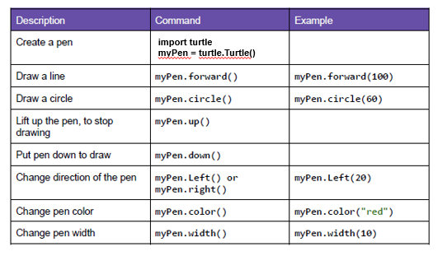

1. Use the following program to draw a red square.

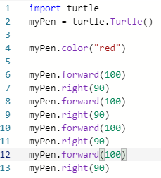

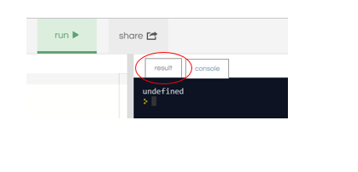

1. Switch to the “Result” window to see the square.
2. Create a program to draw any one of the shapes “b”, ”d”, or “e” shown in the figures below.   
   Provide a listing of your program code

import turtle

myPen= turtle.Turtle()

myPen.color("red")

myPen.forward(100)

myPen.right(90)

myPen.forward(20)

myPen.right(90)

myPen.forward(100)

myPen.left(90)

myPen.forward(100)

myPen.right(90)

myPen.forward(20)

myPen.right(90)

myPen.forward(100)

myPen.left(90)

myPen.forward(100)

myPen.right(90)

myPen.forward(20)

myPen.right(90)

myPen.forward(100)

myPen.left(90)

myPen.forward(100)

myPen.right(90)

myPen.forward(20)

myPen.right(90)

myPen.forward(100)

myPen.left(90)

1. Create a program to draw any one of the shapes “c”, or “f” shown in the figures below.   
   Provide a listing of your program code.

import turtle

myPen= turtle.Turtle()

myPen.color("red")

myPen.forward(100)

myPen.right(90)

myPen.forward(100)

myPen.right(90)

myPen.forward(100)

myPen.right(90)

myPen.forward(100)

myPen.right(90)

myPen.up

myPen.right(90)

myPen.forward(50)

myPen.down

myPen.color("blue")

myPen.circle(50)

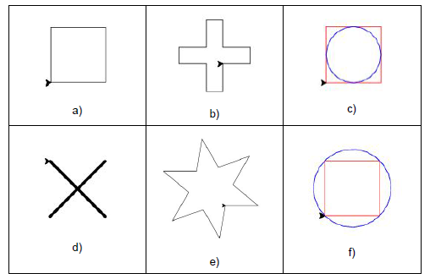

**Step 2: Christmas / Winter Theme Card**

1. Use your creativity to create a card design using Turtle.
   1. The design must have multiple figures.
   2. The design must have at least two different patterns.
   3. You may repeat patterns.
   4. Provide a listing of your program code.
   5. Provide an image of your program result.
2. import turtle
3. import random

6. wn = turtle.Screen()
7. wn.bgcolor("#EFECCA")
8. wn.setup(width=250, height=250)

11. turtle = turtle.Turtle()
13. colors = ["#7D8A2E", "#263248", "#FF8C00", "#F0C600"]

16. def snowflake(size, pensize, x, y):
17. """ function that draws a snowflake """
18. turtle.penup()
19. turtle.goto(x, y)
20. turtle.forward(10*size)
21. turtle.left(45)
22. turtle.pendown()
23. turtle.color(random.choice(colors))
25. for i in range(8):
26. branch(size)
27. turtle.left(45)


31. def branch(size):
32. for i in range(3):
33. for i in range(3):
34. turtle.forward(10.0*size/3)
35. turtle.backward(10.0*size/3)
36. turtle.right(45)
37. turtle.left(90)
38. turtle.backward(10.0*size/3)
39. turtle.left(45)
40. turtle.right(90)
41. turtle.forward(10.0*size)
43. snowflake(8, 6, 0, 0)

46. wn.exitonclick()
47. 